

RT Systems Lab

**Weekly Report number (0)**

Julian Ewaied 215543497 Namir Ballan 326165156

Contents

This Week's Tasks 3

Tasks Done 3

Understanding the project 3

Running a sample code 3

Understanding files formats 4

Files Format 4

Building minimal environment 5

# This Week's Tasks

* Understanding the problem
* Building minimal coding environment
* Understanding the data formats and choosing one
* Running sample code
* CSV files reader class implementation

# Tasks Done

## Understanding the project

We analyzed the used methods for 3D mapping using a camera and a raspberry pi microprocessor. We understood the computational and physical limitations we have, and chose our project.

Our project focuses on building a 3D model of a rooms using only pictures in which we know where the camera vertically is, and therefore using two or more locations in different frames of the same point using motion vectors to match (which is fast since it is done in the hardware), we can calculate the coordinates of a point, and hence build a depth map of the room as a points cloud as we will be discovering more details later on. Notice that this project has been implemented previously, but didn’t use MV's effectively as we will do to approximate the numbers. More details to be explained in later reports.

## Running a sample code

We are planning on using C++ to code, but since most modules which support raspberry pi are in python, we decided to first try to use the already existing python interface. We had actual data from the lab using a drone, and a python code to try see how things work in the project with simple interfaces. We had a 3D coordinates table of all the feature points, and had to make a top-view 2D map of the room. With simple coding we managed to do that- here's the code we wrote:

def topdown_view(depth: np.ndarray):

    depth[:, 2] = np.clip(depth[:, 2], 0, 700)

    depth[:, :2] = np.squeeze(cv2.undistortPoints(depth[None, :, :2], cam_mat, dist_coeff))*depth[:, 2:]

    # empty picture

    pic = np.full((350,350,3), 255,dtype=np.uint8)

    for d in depth:

        cv2.circle(pic, (int(d[0]), int(d[2])), 4, (0,0,0), 1)

    return pic

the results are not very promising:

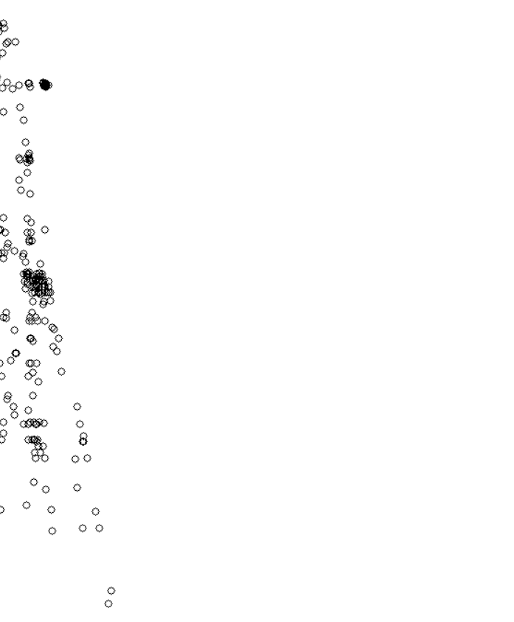

We also ran an already-existing code in order to see what data we have – here's an example:

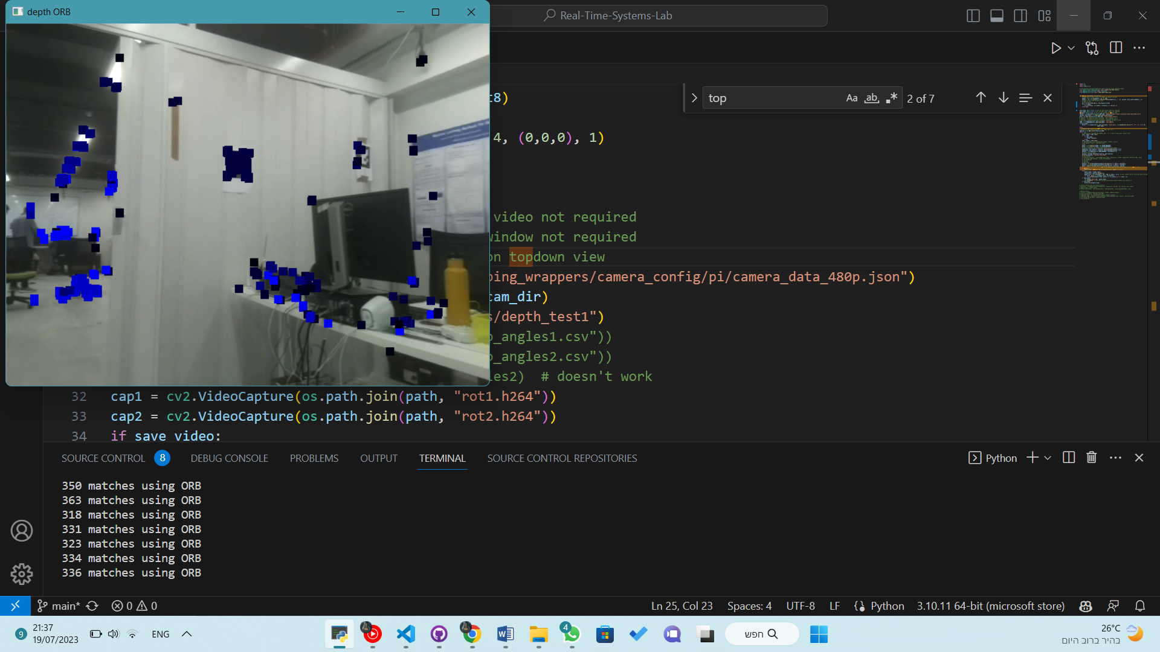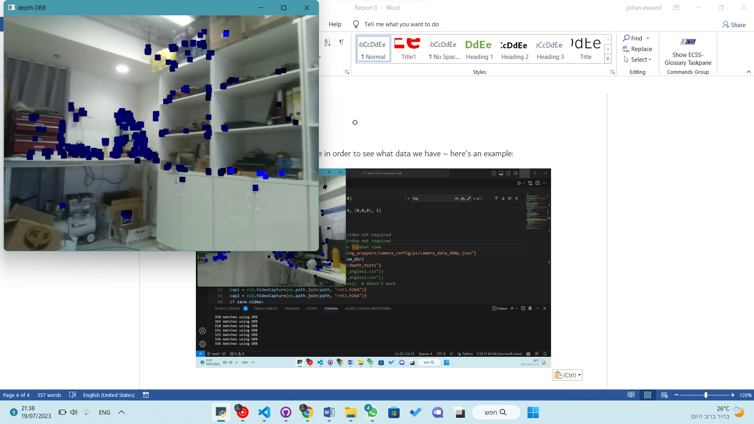

## Understanding files formats

At first, we tried to work with HDF5 files. We found it very complex for our purpose, so we decided to use a library called cnpy with npy files which required a header file called zalib.h, which was not found on our machine. After a long fight with the code we decided to convert the data into csv files. We wrote a python code that takes a path to an .npy file, and using python API writes the relevant data into the csv file in the line format: .

## Building minimal environment

We tried to run the C++ code, but it didn't work in visual studio environment, so we had two options:

1. To use a complex shell code and .json file to use some C++ compiler we don't have yet.
2. To build a .sln file in the repository, which makes a lot of irrelevant files
3. Eventually we did a clever solution to combine both. Here's a diagram that explains the concepts.

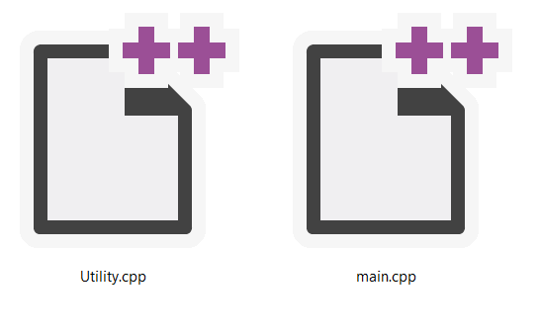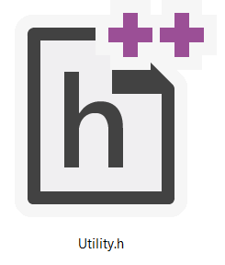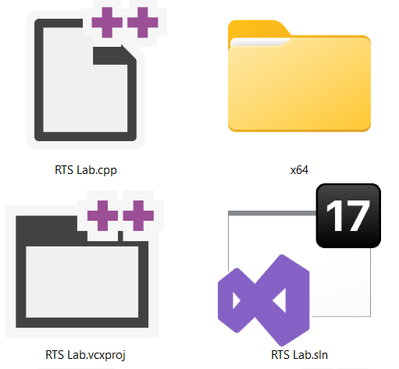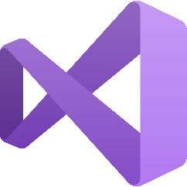

This way, only the relevant code and the reports are transmitted to the Github repository, while the building files are put in a different directory, which has its own main file (RTS lab.cpp in this case), which calls for the main function in the repository, and this way we can run the code easily with visual studio, and not get the build files. Further information about how to install the repository can be found in the readme file in the repository. Here is the repository link.



Github Repository

## Implementing CSV reader class

# Next Week's Tasks

* Understanding the camera matrix
* Understanding the trigonometry to calculate the points
* Installing Eigen library for matrix calculations
* Implementing the calculations